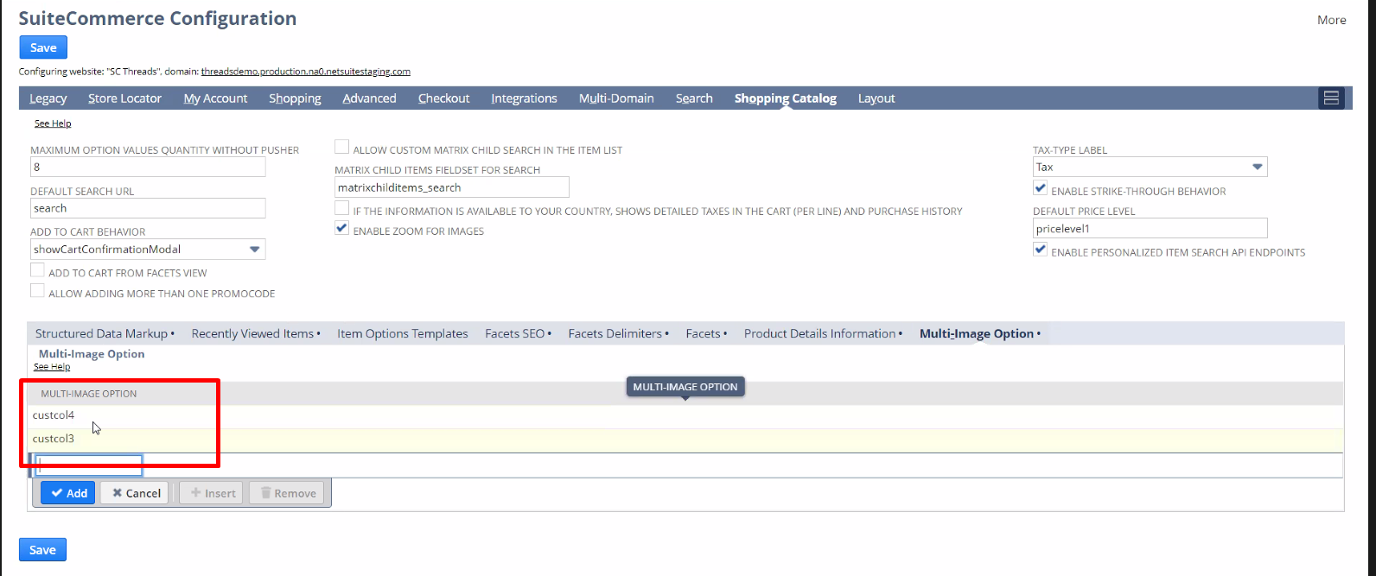
Transaction item options we should change the images there.
Agregar las item options para el item swap, y no pueden porque dice eso de configurationMain.json

www.national
Be able to fill up this table with the data that we want, overwriting the configuration record on SCA mont blanc.
However we can not access the configuration record, the only way is via javascript. Can this be done?
My only idea is the configuration.json.

Poder llenar la tabla esa con lo que queramos, sobreescribiendo el configuration record en SCA mont blanc.

No se puede hacer desde el configuration record porque no podemos acceder.
Hay que hacerlo directamente configurando con javascript.

Del Support case:
Based on my findings, the SuiteCommerce Configuration feature doesn't support old SuiteCommerce Bundles. To be specific, prior Vinson versions. As per initial checking, your current website touch point is running with the SCA Mont Blanc version. See SuiteCommerce, SuiteCommerce MyAccount, and SuiteCommerce Advanced Release Notes article for previous release SCA versions.
Once the feature is used using unsupported touchpoints, It will throw an error saying "No manifest was found by configurationManifest.json" and because of that the behavior that we encounter is indeed the expected behavior.
In addition, configurations for this version of SuiteCommerce Advanced are possible through modifying the JavaScript configuration files.
This configuration method is available for SuiteCommerce, SuiteCommerce MyAccount, and the Vinson release of SuiteCommerce Advanced and later. When configuring the Mont Blanc or Denali release of SCA, you must customize JavaScript configuration files. See the Develop Your SCA Customization article for more details.

Averiguar que tanto tiempo consumiría eso, y decirle al cliente.
Si es algo que supera las 5 / 10 hs probablemente tendrá que ser otro job aparte

They do not have configuration record.
You can change that on core, but it will be hardcoded.

I need access to where the code is, or an external git repository.
On this kind of project, we deploy the full core.

If I do a deploy I will overwrite the whole website

